Newspaper Archive is a BadgerLink database that offers SOME U.S. newspapers between 1752 and the past year or so, SOME Wisconsin newspapers between 1813 and 2016, and SOME La Crosse newspapers between 1852 and 1970. In particular, SOME La Crosse Tribunes are available from 1905 to 1952 as well as 1959 and 1970.

- These directions are based upon using Mozilla Firefox or Chrome as the browser.
- Do not Google NewspaperARCHIVE to access this database unless you want to pay
a $49.95 annual subscription fee.
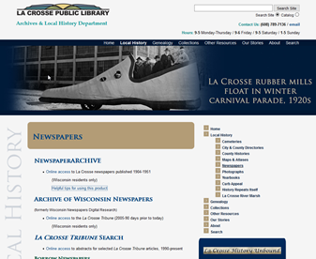
- From the La Crosse Public Library Archives page that you are on, select “NewspaperARCHIVE” or “online access.” If a security warning pops up, select “Continue.”

Since NewspaperARCHIVE is part of BadgerLink, an online library paid for by Wisconsin taxpayers, you may only be able to access this newspaper database if you are a Wisconsin resident, if you are a Wisconsin public school or college student with access to Blackboard via your school, and/or if you are using a computer in a Wisconsin Library. If none of these descriptions are true of you, you will need to obtain a Wisconsin public library card. For a La Crosse Public Library card, go to the La Crosse Public Library home page, select “Services,” and then select “Account & Borrowing,” to read about “Getting a Library Card.” If you do experience difficult signing in to NewspaperARCHIVE, contact BadgerLink at (888)572-5543 or https://badgerlink.dpi.wi.gov/ask-librarian. Please have your library card/account number handy.

Before searching, clear your browser’s (i.e. Internet Explore, Mozilla Firefox, Chrome, etc.) cache if you have not done so for a while. If not, NewspaperARCHIVE will be exceptionally sluggish. To avoid that, open another tab on your computer, and Google something like this: “how to clear cache in Firefox.” Follow the directions in the results that appear.

You can use NewspaperARCHIVE without an account, but creating a FREE account will allow you to easily save your “finds” for easy reference and access at a later time. To create your account in less than 30 seconds, select “Create Free Account” from the black menu near the top of your screen. This is circled in yellow in the screenshot at the top of the next page.

2. At this point, you have four options – as explained in each of the columns below – for searching.
As you search, capitalization is irrelevant. In addition, special characters, such as punctuation marks, are not allowed. In particular, quotation marks are unnecessary around search terms. Periods are not typed after initials/names.

Basic/Quick Search  (name or keyword) | Advanced Search | Browse by Location | Browse by Date
You MAY type in a search term at the very top of your screen, and select the green “Search” button. Or, if you scroll down below the image of students, you could type in the last name of a person (first name is optional), or select the “Keyword” tab and type in a phrase like Scotty Mitchell lynching or Town of Campbell annexation. Either way, with this basic/quick search, you are likely to get a plethora of results, many of which may be irrelevant. Of course, at that point, you could refine your result. By using the options along the right side of your screen, you could narrow the number of results by location and/or date. You will have to select “Submit Query” for each refinement that you make. | 1. Select “Search” from along the top black menu. (See above.)  2. If you are searching for a person, type in the last name and possibly even the first name.  3. If you are searching for an event, issue, or inanimate object (e.g. brothels or ice cream parlors), type in the text that you think will be most helpful.  4. If you are interested in a particular time period, input the appropriate dates.  5. Chances are, you will want to respond to the “Narrow by Publication Location” information. However, unless you know the exact publication that the information you desire appeared in, don’t select anything for the “Publication” box on the far right. By doing so, NewspaperARCHIVE will search ALL of its newspapers from that locale, not just the one that you selected from the drop-down menu. | 1. Select “Browse by Location” from along the top black menu. (See above.)  2. You may select a country or a state. To do so, select the circular icon for the desired country or state.  3. You may want to select a city.  4. You could even narrow to one publication.  5. Now, using the search box on the left side of your screen, you may type in a first name/initial (optional), last name, and/or a keyword phrase. Or, you could select “Go to Advanced Search” and conduct an advanced search. If doing so, follow #2-#6 in the column to the left of this one. | 1. Select “Browse by Date” from along the top black menu. (See above.)  2. Scroll down and select a century from the red text options.  3. You may select a year.  4. You could even select one publication.  5. Follow #5 in the column to the left of this one, OR, if you know the exact date you would like to search, you must select a publication. (Step #4 above.) Then scroll down to see the available years. Select the year. Scroll down again to select the day. If your year and/or day to do not appear in the listing, that particular newspaper is not available in NewspaperARCHIVE.

If you have questions as you search, select “Help,” which is circled in red above. The Frequently Asked Questions and Take a Tutorial options are particularly helpful. However, some information is outdated.
3. If there are no results, limited results, or undesirable results, you could click on the orange “Revise your Search” button and modify the search.
4. As you look through the results, some of the text might appear to be “gibberish.” This is the because of the OCR (Optical Character Recognition) readers that are used to scan print newspapers and then digitize them. Regardless, select the title of the newspaper for any result that you would like to read in greater detail.
5. WAIT PATIENTLY for your article to appear! (If you did not clear your cache, as explained in the second suggestion on page 1, you may want to do so now. That should speed up the process.)

6. What appears on your screen should look like the image below. You should see a red JPEG viewer across the top of the page and a thumbnail image (i.e. a navigator) in the upper right of the viewer. (The thumbnail can be moved around.) In addition, letters or words from your search term should be highlighted in yellow throughout the newspaper page.
1 2 3 4 5 6 7 8 9 10 11 12 13 15 14 16

1. Select this to see in full screen mode. If you select it a second time, it will revert back to a partial screen.

2. Select this to save the image (i.e. picture of the newspaper page) a number of different ways:
- as an e-mail to yourself
- as a PDF (even though you are using a JPEG viewer) that will give you a clear image of the entire page; if you print this PDF, the text probably won’t be readable unless you can print on 11” X 17” paper and, even then, the text will be small.
- as a JPEG image of the entire page that you could print in full or crop, by using another software such as Paint or Adobe PhotoShop, to get a close-up view of the desired article
- as a component of your NewspaperARCHIVE treasure box, an online folder system for organizing NewspaperARCHIVE articles that are of interest to you (You must have a NewspaperARCHIVE account, which is FREE, to create the treasure box.)
- as an image that you can share with others via e-mail OR link to your web site/blog when you save it to your personal archive (To do so, you must have a NewspaperARCHIVE account, which is FREE.)

3. There are two options for printing:
- You can print this entire page from your local printer, but it will print on several sheets of paper. It would be better to print the entire page as a PDF or a JPEG, as explained under #2 on page 3.
- You can put this page in your personal shopping cart and pay $29.95 for the printout.
In most cases, you will only want to print the desired article. To do so, follow the directions on pages 5-8 of this document.
4. Select this to cut/crop the article and then print and/or save from there.

5. This controls the brightness and darkness of the black print on the white background.

6. Use this to zoom in and make the text and images larger. This could also be accomplished by a forward motion on the roller atop a mouse.

7. Use this to zoom out. Moving backwards on the roller atop a mouse will also make images smaller.
The thumbmail image/navigator on the right side of the screen can help you see where you are in relation to the entire newspaper page. It can be selected and then moved/dragged to different spots on the screen

8. Select this to see the front page of the newspaper.

9. Select this to go back (“rewind”) one page.

10. This tells you that you are on page 1 of this twelve-page newspaper.

11. Select this to go to the next page, which would be page 2.

12. Select this to see the last page (page 12) of this newspaper.

13. This shows the search term that you used. The term should be highlighted in yellow each time that it appears on the page. If you wanted to see how often another search term appears on the page, type in a new term (in #13).

14. Then, select this magnifying glass, or hit “Enter” on your keyboard to see occurrences of the new search term.

15. Use these arrows to see the new search term highlighted in yellow on the page.

16. This is your shopping cart where you can purchase printouts. Each is $29.95.

7. To navigate around the page and see various portions/articles, select (i.e. click) anywhere on the page, and use your mouse or your touchpad to drag around the page to modify what is visible.
8. Once you locate the desired article and peruse it, if you decide it is irrelevant, you could select “Back to Search Results,” and continue searching.
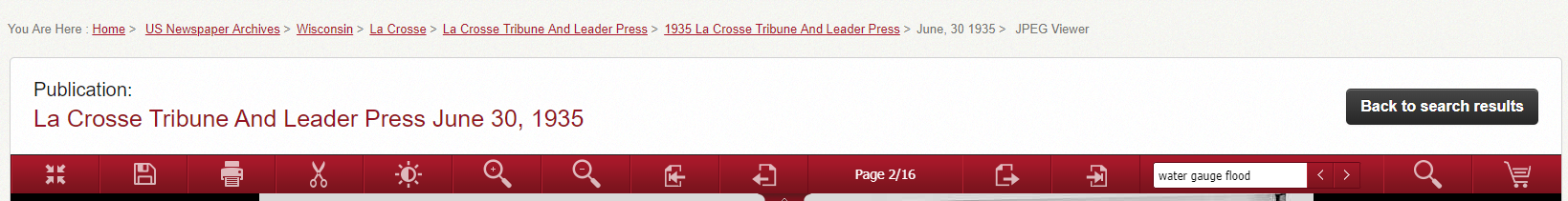
9. But, if you find a helpful article and would like to save or print it, follow these directions:
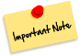
If you are logged into your NewspaperARCHIVE account, you can select the red “save result” button from the results listing to save an article. Other options for saving are explained with #2 on page 3 as well as below.

If what you desire is from a La Crosse newspaper, there’s a great chance that the article is available on microfilm, and you may find it easier to print from microfilm than from NewspaperARCHIVE itself. If so, simply record the newspaper name, the date, and the page number somewhere. Then, visit the La Crosse Public Library Archives Dept. on the 2nd floor of the main library at 800 Main Street. Staff can assist you with using the microfilm machine and making a copy.

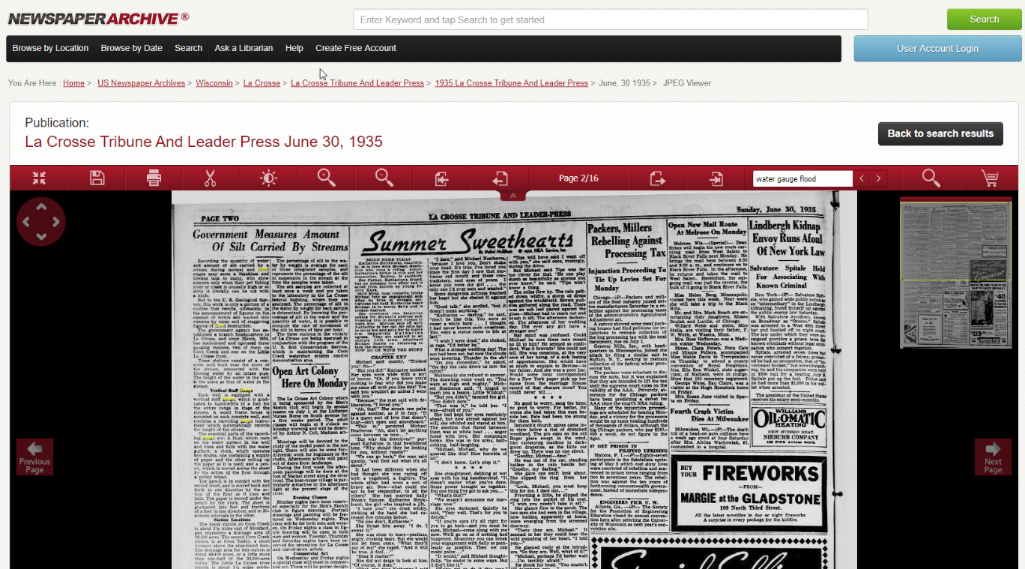
- Make sure you have full screen view. The icon on the far left should look like this one. If not, select the icon so that it changes and matches this icon.

NOTE: In some cases, to see the entire article for cropping purposes, especially if the article spans up and down one or more columns, you may need to zoom out, as was done here (below) with columns 1 and 2.
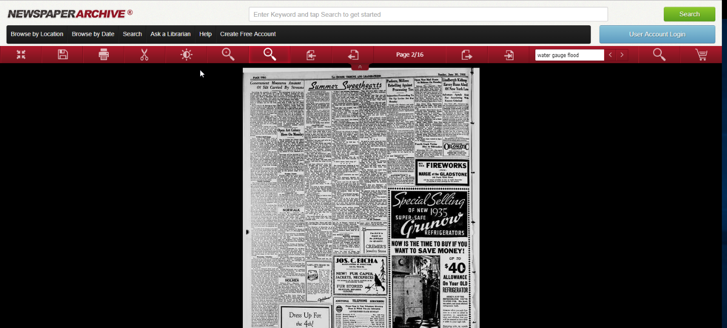

b. Select the crop tool.

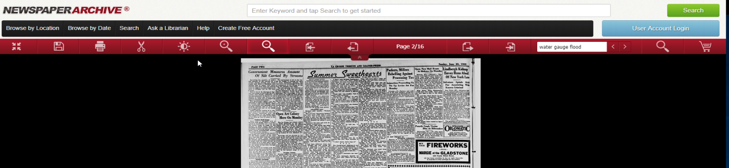

c. Click on the dashed square.

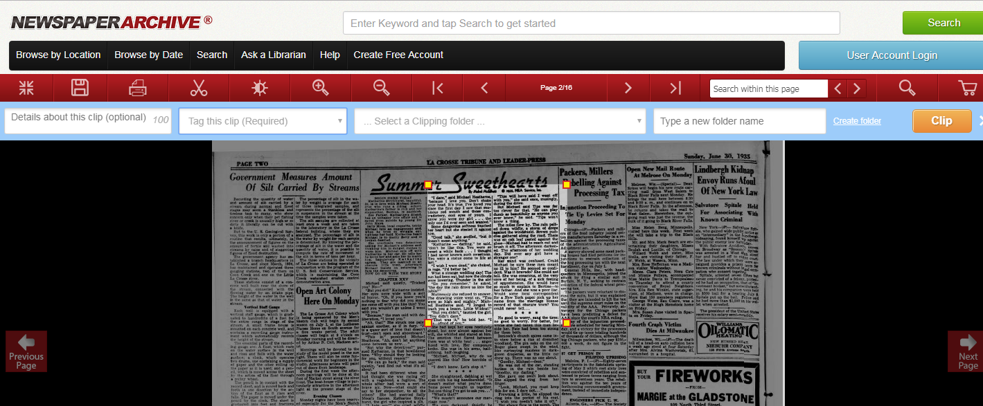
d. A box for cropping will then appear. In the image below, the cropping box has a yellow square in each corner.

e. Before cropping, you MUST select one of the alternatives under the second option on the upper right of the screen: “Tag this clip (Required).” This truly is a meaningless step in the process unless you are saving to your treasure box or personal archive, (See #2 on page 3.) but NewspaperARCHIVE requires it. So, select any of the alternatives except for “Other Articles.” In the example on the next page, “Anniversary” was selected.

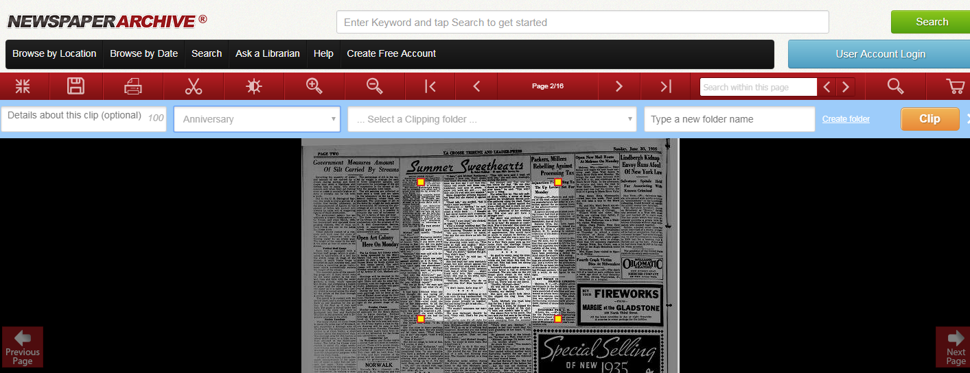

f. Now you may crop by selecting and then dragging the cropping box so that it outlines the desired article or portion of the page. The cropped article below spans the entire first column and part of the second column.

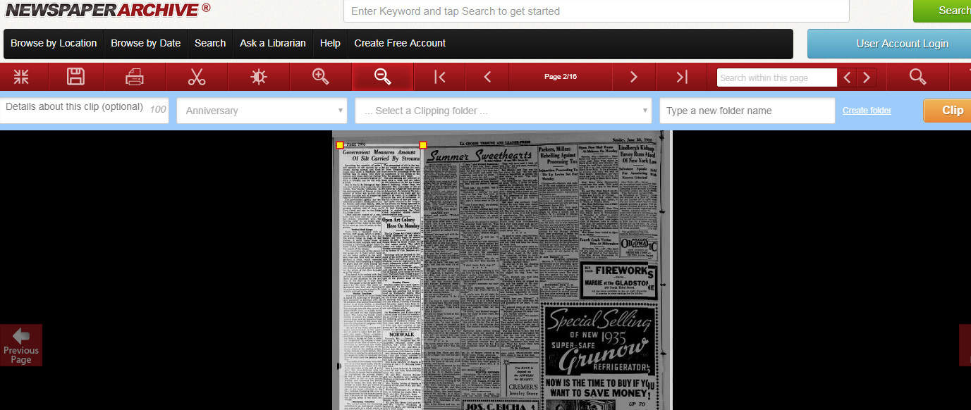

g. Now, select the orange “Clip” button in the upper right. (See in the image above.)

h. Once it is clipped, then you may select the orange “Download” button in the upper right. (See in the image below.)

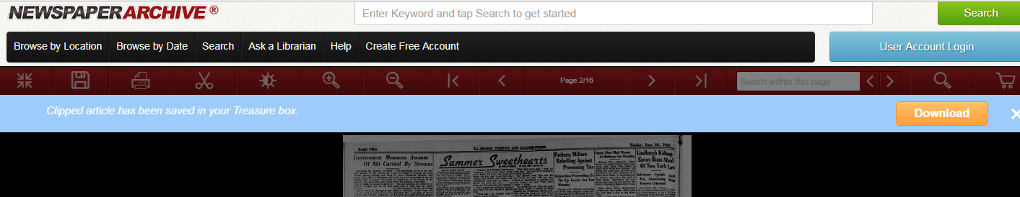
- In Chrome, the download will appear on the lower left, as depicted below. Select it to open it.
- In Firefox, a box will appear. Either select “save” or “OK.” Then, from your browser’s downloads (the downward arrow near the upper right of the screen), you may open the download in your preferred software.
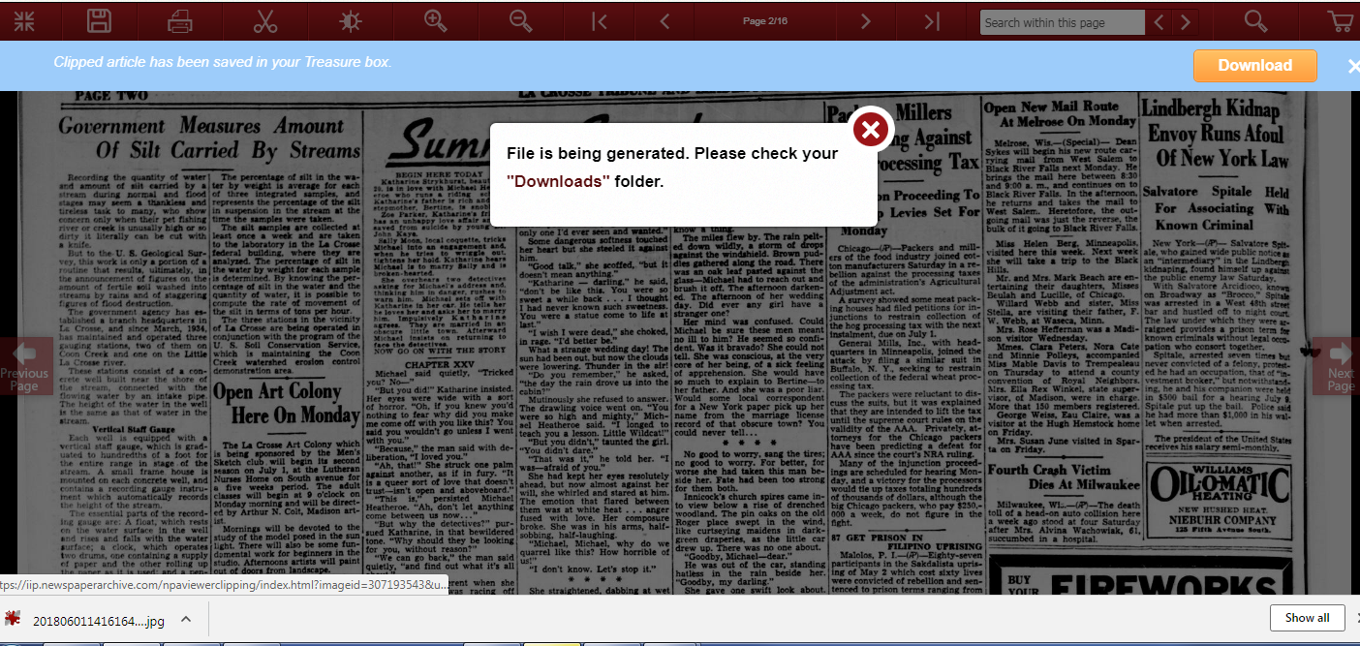
i. At this point, you could save the image to your computer/device or a flash drive, you could print it, and/or you could e-mail it.
- If you are saving, go to “FILE” and “Save” in Firefox. In Chrome, click on the three dots in the upper right corner and “Copy” or “Save as.” After selecting a destination for the file, you could use the newspaper title, date, and page number for the file name or as part of the file name. By doing so, you will then have the source information for citation purposes or for re-locating the article at a later date.

- If printing from Firefox, before selecting “Print,” select “best fit to page.” In Chrome, click on the three dots in the upper right corner. For print settings, select “full page” for photo size and “shrink to fit.” Once you have printed, record the name of the newspaper, the date, and the page number on the printout. This will help with citing the article or accessing the article again, if needed.

- If you are e-mailing, you will need to open your e-mail account and attach the downloaded file. In the subject line or in the e-mail message itself, type the newspaper title, date, and page number so that you have the citation information.
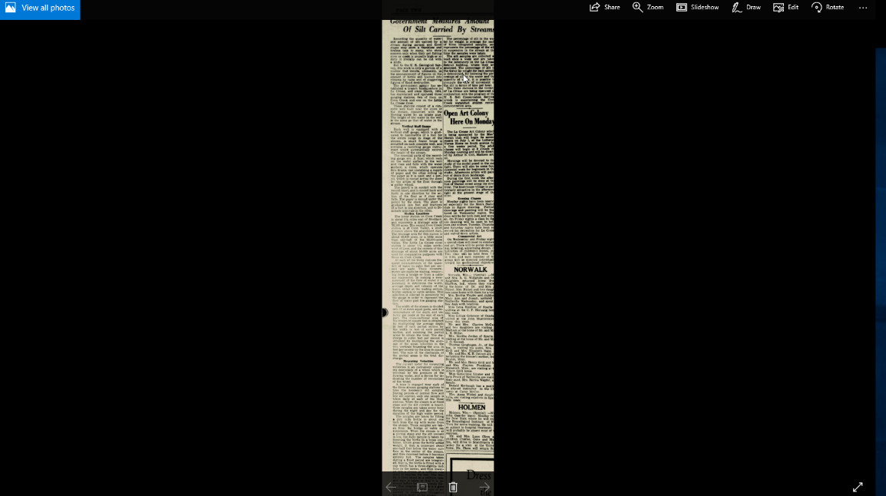
In Chrome, the print, copy, and/or save options are located in the upper right corner. Select the three dots.

Edit

After using NewspaperARCHIVE, If you are still seeking more newspaper articles, check out these possibilities:
For Wisconsin-based information between the 1800s and 1900s, search the Archive of Wisconsin Newspapers, which is also available from the newspaper resources on the La Crosse Public Library’s Archives’ web page (http://badgerlink.newsmemory.com/wna/badgerlink/). Archive of Wisconsin Newspapers offers 22 Wisconsin newspapers from the 1800’s and 1900’s. To access these “old” papers, click on the red “Select Historical Newspapers” icon. (This database is part of BadgerLink, so as explained on page 1, you will need to be “BadgerLink approved.”)
If you desire La Crosse information from about 1951-1963, a time period that is barely covered by NewspaperARCHIVE, or worldwide information from the 1700’s onward, you could search Newspapers.com at https://www.newspapers.com/ . Anyone who lives in the city of La Crosse, has paid the $44.95 subscription fee, or has an Ancestry.com subscription has full access to this database and can view entire articles. Those who do not can still see the citations for articles, but that’s it. Yet, with the citation, you could print and/or save the article by using microfilm at the Archives Department.
- To locate local history on Newspapers.com without a subscription, click on Browse United States Wisconsin La Crosse and then La Crosse Tribune. You can also specify the date range. Do not limit by publication. When you search and find something of interest, be sure to record the full date
and page number so that you can view the article via microfilm at a later date. (NOTE: You can
also use this technique to find articles between 1963-1977 that will not appear even with a subscription.)
- With a subscription, select “Research” from the La Crosse Public Library home site: http://www.lacrosselibrary.org/ Under that, select “All Resources.” If you are searching for local history, rather than typing a search term, select “See papers by location.” Using the map, narrow in on La Crosse. Then, type your search term in the upper right.
For La Crosse news since 1976 -- and even a limited amount of news before then--, check out the La Crosse Tribune Search (http://archives.lacrosselibrary.org/local-history/newspaper-info/newspapers/), an index created by the La Crosse Public Library Archives staff. On occasion, you can click on an URL that will bring up the article. But, in most cases, to see the article, you would either need to use the microfilm in the Archives Department or ask to see newspaper clipping file(s).
For even more recent Wisconsin news, use the Archive of Wisconsin Newspapers (http://badgerlink.newsmemory.com/wna/badgerlink/) to access 256 newspapers, including the La Crosse Tribune and Onalaska Holmen Courier Life from 2005 and up to 90 days prior to today’s date. Coulee News is also available from 2010 and onward. Since The Archive of Wisconsin Newspapers is part of BadgerLink, to access it from this link or from the Archives web site, you will need to be “BadgerLink approved.” See page 1.
Yet another resource is Newspaper Source Plus. It claims to offer all La Crosse Tribune articles written by staff members from 2006 and onward as well as articles from 1,209 other newspapers. To access Newspaper Source Plus, go the La Crosse Public Library web site, and select “Research” from the options beneath the logo and contact information. (If you are not “BadgerLink approved, as explained on page 1, this might be all the further you get.) From there, select “All Resources.” From the alphabetical listing, select “BadgerLink.” Once in BadgerLink, click on the “N” and then select “Newspaper Source Plus. Click on the blue “Advanced Search.” Lot of options now appear. Before typing in a search term, click “Full Text” under “Limit Your Results” to ensure that all of your results are complete articles, not just citations or abstracts. Now you may type in your search term and any other search parameters you desire. If any results of interest appear, click on the title. Then, you can read the article and decide if you want to e-mail it to yourself to print at a later time, if you want to save it, or if you want to print it; simply select from the icons on the right side of the screen. If you opt to print, always print from the printer icon, not from your browser (i.e. FILE and then “PRINT”) to get the complete article on the least amount of paper and with the full source/bibliographical information.
You may find it easiest to locate recent La Crosse Tribune articles by searching the La Crosse Tribune web site.
Better yet, ask the Archives Department if there are any print clippings from the La Crosse Tribune on our topic. The staff has clipped numerous articles that go as far back as 1852 with the greatest coverage from 1970 and onward.
And, you can always contact the Archives Department with questions by clicking on this icon on the Archives web site.

La Crosse Public Library
The Archives is located on the second floor of the library.
800 Main Street
La Crosse, WI 54601

(608)789-7136 archives@lacrosselibrary.org

